**LABORATORY WORK №13**

**Topic: «Infrastructure Electronic Government.»**

**Purpose:** forming the students' holistic view of nature information and communication technologies and their potential application in the organs public authorities in order to improve the efficiency of public administration ; development of management skills by using internet technology .

The primary delivery models of e-government can be divided into:

* [Government-to-citizen](https://en.wikipedia.org/wiki/G2C) or government-to-consumer (G2C)
  + In this model, the G2C model apply the strategy of customer relationship management (CRM) with business concept.
  + By managing their customer (citizen) relationship, the business (government) can provide the needed products and services fulfill the needs from customer (citizen).
  + In United States, the NPR ([National Partnership for Reinventing Government](https://en.wikipedia.org/wiki/National_Partnership_for_Reinventing_Government)) has been implemented from 1993.
* [Government-to-business](https://en.wikipedia.org/wiki/Government-to-business) (G2B)
* [Government-to-government](https://en.wikipedia.org/wiki/Government-to-government) (G2G)
* [Government-to-employees](https://en.wikipedia.org/wiki/Government-to-employees) (G2E)

Within each of these interaction domains, four kinds of activities take place:[[13]](https://en.wikipedia.org/wiki/E-government" \l "cite_note-13)[[14]](https://en.wikipedia.org/wiki/E-government#cite_note-14)

* pushing information over the Internet, e.g.: regulatory services, general holidays, public hearing schedules, issue briefs, notifications, etc.
* two-way communications between the agency and the citizen, a business, or another government agency. In this model, users can engage in dialogue with agencies and post problems, comments, or requests to the agency.
* conducting transactions, e.g.: lodging tax returns, applying for services and grants.
* governance, e.g.: To enable the citizen transition from passive information access to active citizen participation by:

1. Informing the citizen
2. Representing the citizen
3. Encouraging the citizen to vote
4. Consulting the citizen
5. Involving the citizen

There are also some technology-specific sub-categories of e-government, such as [m-government](https://en.wikipedia.org/wiki/M-government) (mobile government), u-government (ubiquitous government), and g-government ([GIS](https://en.wikipedia.org/wiki/GIS)/[GPS](https://en.wikipedia.org/wiki/GPS) applications for e-government).

The primary delivery models of e-government are classified depending on who benefits. In the development of public sector or private sector portals and platforms, a system is created that benefits all constituents. Citizens needing to renew their vehicle registration have a convenient way to accomplish it while already engaged in meeting the regulatory inspection requirement. On behalf of a government partner, business provides what has traditionally, and solely, managed by government and can use this service to generate profit or attract new customers. Government agencies are relieved of the cost and complexity of having to process the transactions.

To develop these public sector portals or platforms, governments have the choice to internally develop and manage, outsource, or sign a self-funding contract. The self-funding model creates portals that pay for themselves through convenience fees for certain e-government transactions, known as self-funding portals.

[Social networking services](https://en.wikipedia.org/wiki/Social_networking_service) are an emerging area for e-democracy. The social networking entry point is within the citizens’ environment and the engagement is on the citizens’ terms. Proponents of e-government perceive government use of social networking as a medium to help government act more like the public it serves. Examples can be found at almost every state government portal through [Facebook](https://en.wikipedia.org/wiki/Facebook" \o "Facebook), [Twitter](https://en.wikipedia.org/wiki/Twitter), and [YouTube](https://en.wikipedia.org/wiki/YouTube) widgets.

Government and its agents also have the opportunity to follow citizens to monitor satisfaction with services they receive. Through ListServs, RSS feeds, mobile messaging, micro-blogging services and blogs, government and its agencies can share information to citizens who share common interests and concerns. Government is also beginning to [Twitter](https://en.wikipedia.org/wiki/Twitter). In the state of [Rhode Island](https://en.wikipedia.org/wiki/Rhode_Island), Treasurer [Frank T. Caprio](https://en.wikipedia.org/wiki/Frank_T._Caprio) is offering daily tweets of the state’s cash flow. For a full list of state agencies with [Twitter](https://en.wikipedia.org/wiki/Twitter) feeds, visit [NIC](https://en.wikipedia.org/wiki/NIC_Inc.). For more information, visit transparent-gov.com.

**E-government portal of the Republic of Kazakhstan** is the information-reference and interactive web portal, providing public services and services in electronic form and providing a single point of access for the most relevant information on public services.

Portal electronic [www.egov.kz](http://www.egov.kz) government developed by the order of the Agency of the Republic of Kazakhstan on communication and information national operator in the field of information technologies of JSC "National Information Technologies", a subsidiary of JSC National ICT Holding "Zerde". In 2015, the development agreement was concluded directly with the company LLP "Bee Software" in the conglomerate to LLP "Inessoft". JSC "National Information Technologies" exercise the functions of project management**.**

Descriptions of public services, divided by sections, consist of the following information:

• Full and short name of the service;

• the name of a state body (organization) - the service provider;

• information about places where you can get information on the procedure for the provision of services;

• Category of recipients of services;

• The term of service;

• The cost of the service;

• action and data necessary for services in electronic form;

• list of documents required to obtain the services of a public body;

• application forms and other documents which the applicant has to fill;

• the result of the provision of services;

• a list of texts and regulations governing the provision of services.

Each sub-section of the portal contains useful articles on common issues for obtaining government services and various ancillary information on topics subsections.

**Block "Citizens and Government"**

• Internet conference

• Discussion of draft

• e-applications

• Appointments to the Minister

• Blogs first leaders

• Officials in social networks

• Government agencies Kazakhstan

• open data portal

**Task 1**

**1.** To obtain government services and information , open the browser and Zayed in the site «http://egov.kz/»

( Figure 1 )

**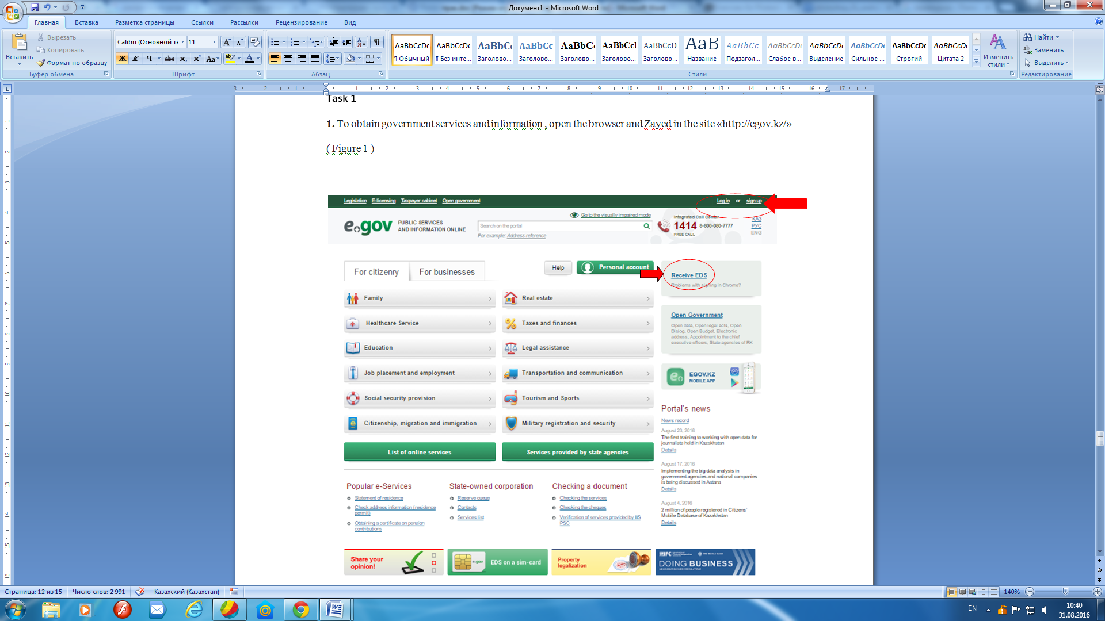**

Figure 1

**2.** To work with the portal to get the " electronic digital signature (EDS ) . " For this purpose :

**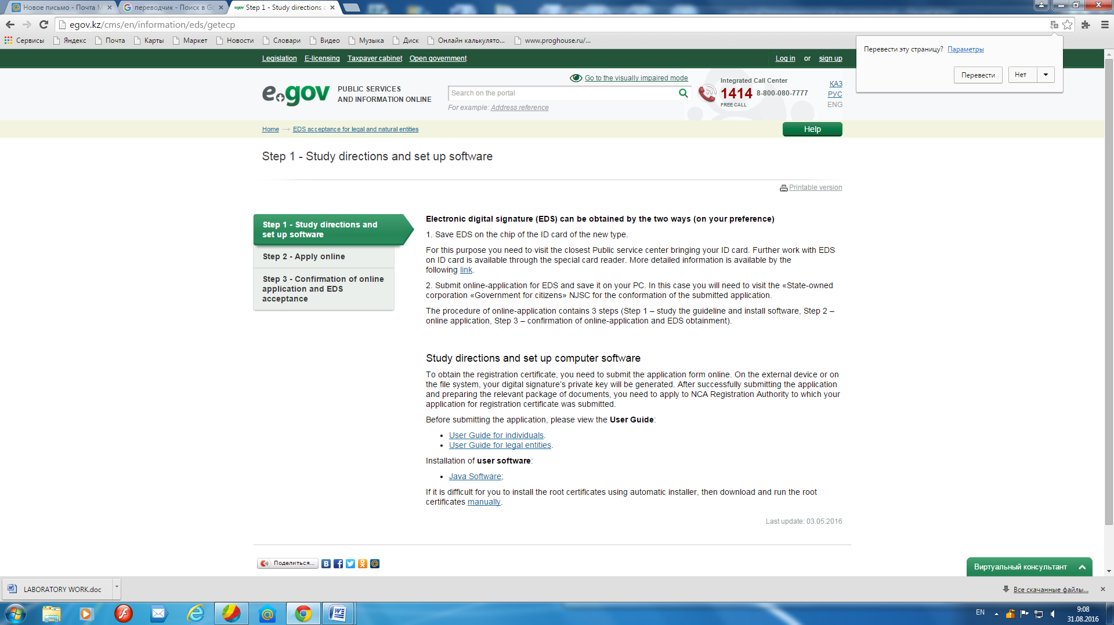**

**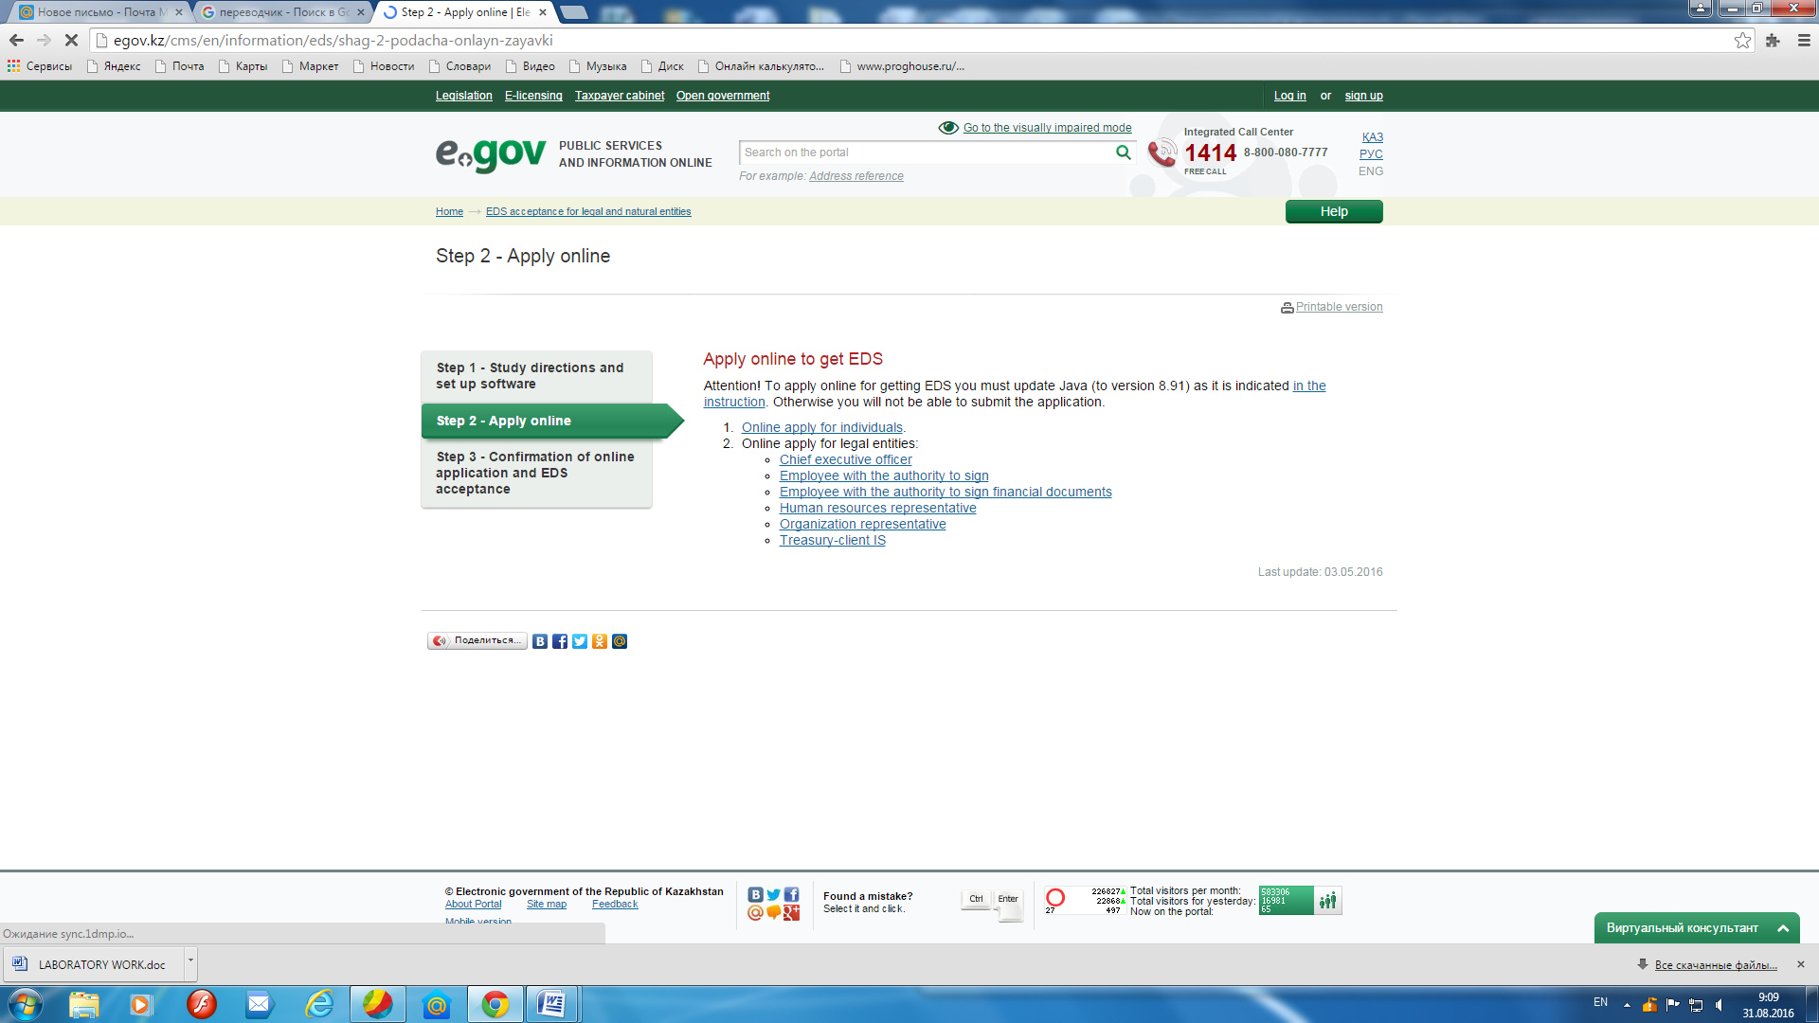**

**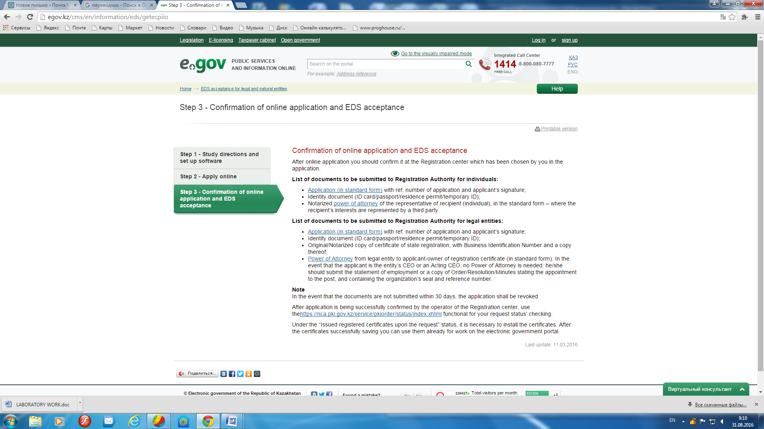**

Figure (a , b, c ) - 2

**3.** After the digital signature will get the ability to send requests for any documentation . Go through the portal and sign up for your personal account ( Figure 3 )

**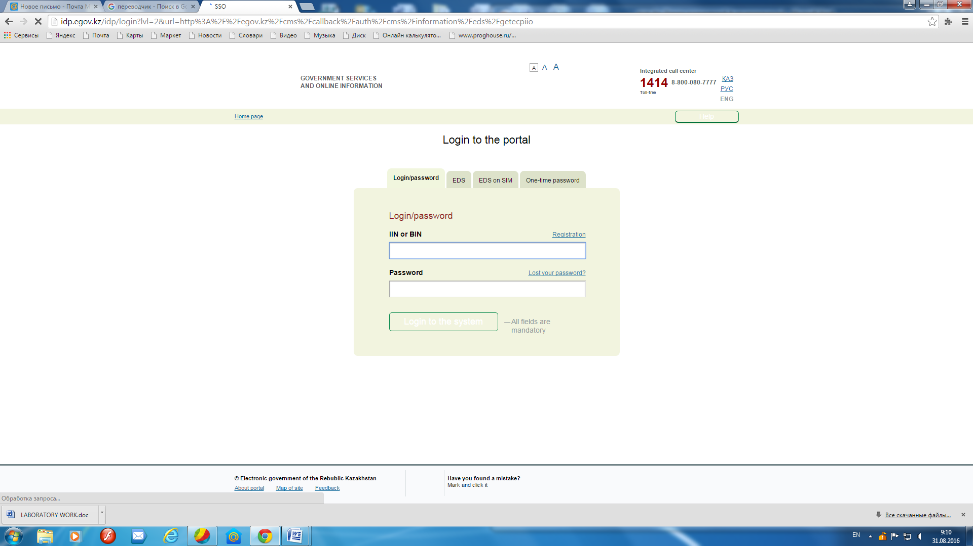**

Figure - 3

Tasks for independent work :

With the help of instructions and videos on the site egov.kz, perform the following task

1. Getting help address

2. Check the address data ( data on registration )

3. Getting Help of pension contributions

Control questions:

1. What does the " E-government " ?

2. Why use the portal "Electronic government" ?

3. What are some ways you can get the " Digital signature " ?

4. What types of online services for citizens , you know?